linear model – chapter 2 excerciseS

**Thanh Doan – Student ID 0159701**

|  |  |
| --- | --- |
| exercise 2.7 |  |

**a - Fit a simple linear model to the data**

* It might be useful to plot a scatter diagram to visualize the data first.

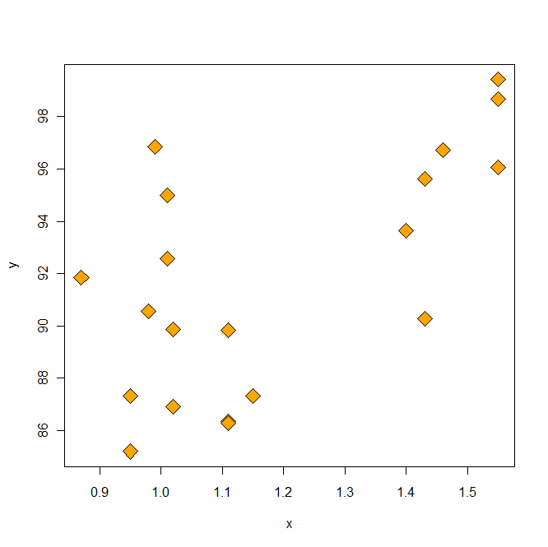

* Fit the linear model. Compute least-square estimation of the parameters by hand (i.e. not using **lm(.)** function provided by R statistical computing language).

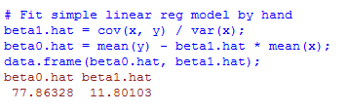

**b – Test the hypothesis $H_{o}: β_{1}=0$**

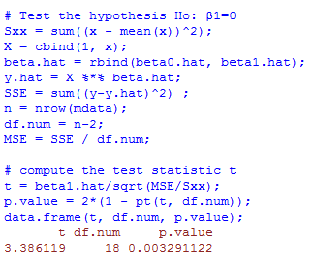

P-value = 0.003. The null hypothesis is rejected at the confidence level 95% (or even 99%) and we conclude that there might be a linear relationship between purity and hydrocarbons.

**c – Calculate $R^{2}$**

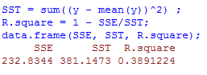

**d – Find 95% CI on the slope**

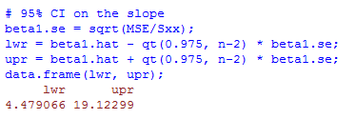

**e – Find 95% CI on the mean y when x = 1.00**

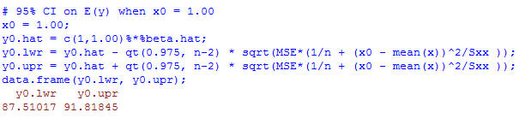

**NOTE**

In practice, we can answer all the 5 questions above easier by using much fewer lines of R code. I.e. if we use convenient built-in functions in R to analyze this dataset, then we can accomplish all the above work with just 4 lines of R code below.

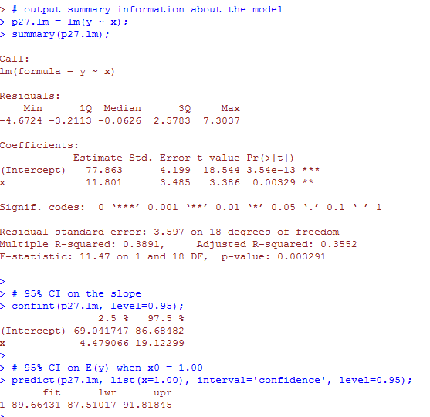

|  |  |
| --- | --- |
| exercise 2.8 |  |

**a – Find the correlation between x and y**

* The correlation $r = \sqrt[2]{R^{2}}= \sqrt{0.3891224} =0.6237968$

**b – Test the hypothesis $H_{o}: ρ=0$**

* This test is basically the same test $H_{o}: β_{1}=0$

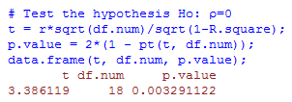

Thus, and we conclude that there might be a linear relationship between purity and hydrocarbons.

**C – Find 95% CI for $ρ$**

The 95% confidence interval for $ρ$ is

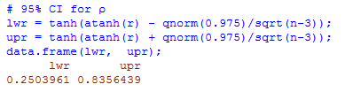

|  |  |
| --- | --- |
| exercise 2.19 |  |

**a –**